# MS45xx Series Surface Models

MS45X5-DSxxxyS  
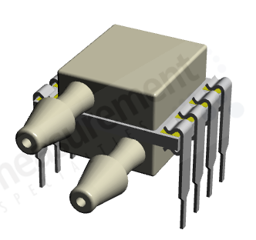 

MS45X5-TPxxxyP  
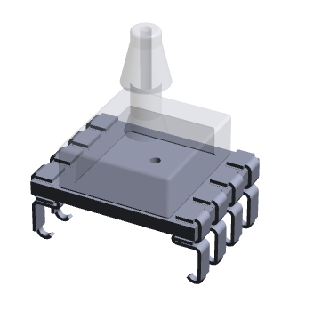

MS45X5-SSxxxyP  
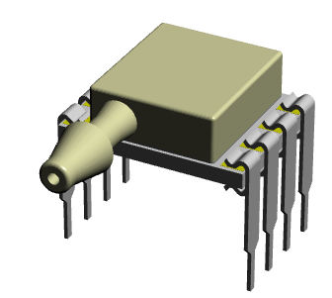

MS45X5-DSxxxyP  
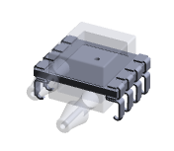 

MS45X5-TPxxxS  
 

MS45X5-SSxxxyS  
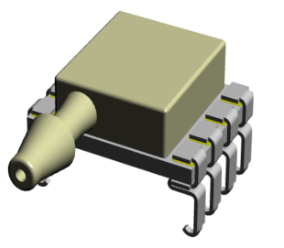 

MS45X5-MMxxxyP  
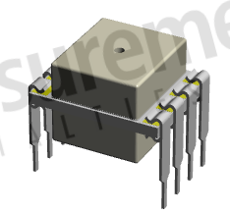 

MS45X5-MMxxxyS  


MS45X5-MMxxxyL  
 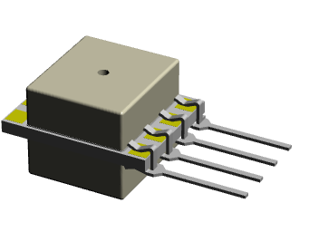 

|  |  |  |
| --- | --- | --- |
| NORTH AMERICA | EUROPE | ASIA |
| Measurement Specialties,  a TE Connectivity Company  45738 Northport Loop West  Fremont, CA 94538  Tel: 1-800-767-1888  Fax: 1-510-498-1578  Sales: [customercare.frmt@te.com](mailto:customercare.frmt@te.com)  **te.com/sensorsolutions**  Measurement Specialties, Inc., a TE Connectivity company.  Measurement Specialties (MEAS), American Sensor Technologies (AST), TE Connectivity, TE Connectivity (logo) and EVERY CONNECTION COUNTS are trademarks. All other logos, products and/or company names referred to herein might be trademarks of their respective owners.  The information given herein, including drawings, illustrations and schematics which are intended for illustration purposes only, is believed to be reliable. However, TE Connectivity makes no warranties as to its accuracy or completeness and disclaims any liability in connection with its use. TE Connectivity‘s obligations shall only be as set forth in TE Connectivity‘s Standard Terms and Conditions of Sale for this product and in no case will TE Connectivity be liable for any incidental, indirect or consequential damages arising out of the sale, resale, use or misuse of the product. Users of TE Connectivity products should make their own evaluation to determine the suitability of each such product for the specific application.  © 2016 TE Connectivity Ltd. family of companies All Rights Reserved. | MEAS Switzerland Sarl,  a TE Connectivity company  Ch. Chapons-des-Prés 11  CH-2022 Bevaix  Tel: +41 32 847 9550  Fax: +41 32 847 9569  [customercare.bevx@te.com](mailto:customercare.bevx@te.com) | Measurement Specialties (China), Ltd.,  a TE Connectivity Company  No. 26 Langshan Road  Shenzhen High-Tech Park (North)  Nanshan District, Shenzhen 518057  China  Tel: +86 755 3330 5088  Fax: +86 755 3330 5099  Sales: [customercare.shzn@te.com](mailto:customercare.shzn@te.com) |

